Spring security using LDAP Protocol

[BASANT KUMAR HOTA](https://www.facebook.com/dugulu)·[SATURDAY, DECEMBER 16, 2017](https://www.facebook.com/notes/sriman_java_gyan_mantra/spring-security-using-ldap-protocol/1525807587504277/)

Let's discuss what is ***LDAP***, what is the purpose to use ***LDAP*** authentication and How it internally works

**what is LDAP:**

***LDAP*** as the name suggests, it is a light weight directory access protocol. so we can't say ***LDAP*** is a server

**Purpose to use:**

Then main purpose to use for authentication , like suppose my application is intranet application which used by very less means countable people

then instead of doing role base Authentication using Database i should use ***LDAP***

It can be used for data which is common and everyone uses. Eg Basic info of employees can be stored since that is used by many teams and many times. Ita faster that traditional RDBMs but it cannot handle huge data.

***To use this you need to follow some basic standard***

1.create a file with extension .ldif (ex : test-server.ldif)

2.Configure there some credential with some patterns like group by people or user means in sort specify the roles with ldif provided patterns

3.For better performance try to load this file while up your application.

**Internal flow diagram:F**

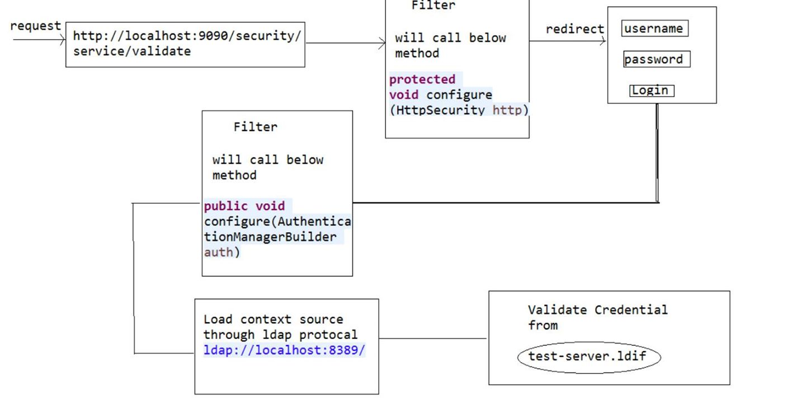

Flow diagram

**Explanation:**

1.When i hit my rest endpoint url i.e [http://localhost:9090/security/service/validate](https://l.facebook.com/l.php?u=http%3A%2F%2Flocalhost%3A9090%2Fsecurity%2Fservice%2Fvalidate&h=ATPCo__XUR0fjzwR5IGR1NrwmzcfSONAzi6tUGAdQPZl-HCvILk0ZL83ighueUEGpbEtuWNIWT53q_fTIE_gaIdilmdI5eAzUQDAPHhI0oRuUtqlvXD68eVFIOROWHP1ft1qTH-kd7_Jjg) then Request goes to Filter and as am following Java base configuration so there is one method like below

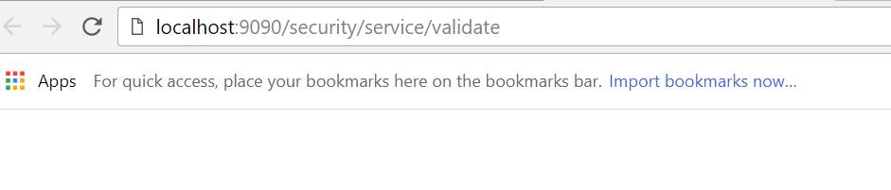

Hit the URL

protected void configure(HttpSecurity http) throws Exception { http.authorizeRequests().anyRequest().fullyAuthenticated().and().formLogin();

}

This method will helps us to redirect login page in any request for authenticate

2.Now Login page will be display then enter your credential once we hit the login button spring security it self build the URL like [http://localhost:9090/login](https://l.facebook.com/l.php?u=http%3A%2F%2Flocalhost%3A9090%2Flogin&h=ATP8aMBhBfuCVI__b4jADW6eaM65PuWKOGuk8n54dxW6z62NutQ9HNiE9Ixps0yvZ8XCAbCuEQM53coefb3Xnk8eLQ-cn38sqTHd8H-4_oYturFg8WkO0l-UbYtHUfEOupZXSjyAh87GPw) and then request again goes to filter with mentioned URL

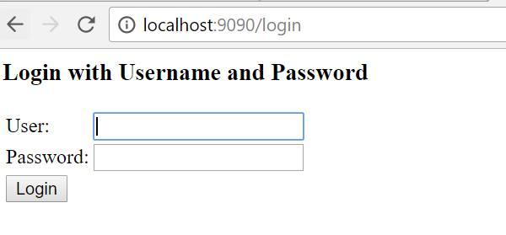

Default Login page provided by Spring

internally it will calls below methods

@Override

public void configure(AuthenticationManagerBuilder auth) throws Exception {auth.ldapAuthentication().userDnPatterns("uid={0},ou=people").groupSearchBase("ou=groups") .contextSource(contextSource()).passwordCompare().passwordEncoder(new LdapShaPasswordEncoder()).passwordAttribute("userPassword");

}

This method helps us to specify the patterns with whom you want to validate your credential with .ldif files

3.if credential is valid then page will be redirect to your service calls

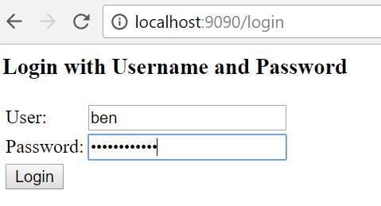

valid crecential

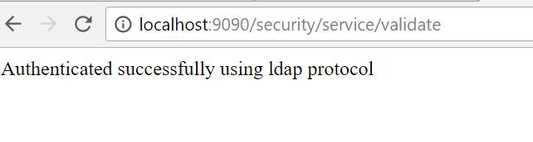

Success

4.if wrong credential

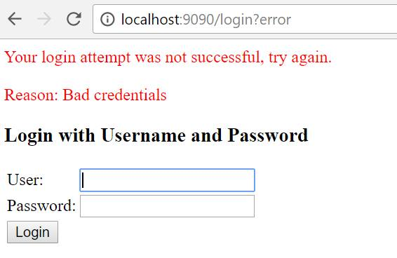

Invalid Credential

If any one want source code can download from below Link

[**Source Code Download**](https://l.facebook.com/l.php?u=https%3A%2F%2Fgithub.com%2FSriman-Java-Gyan-Mantra%2FSpring-security-LDAP&h=ATMgIPJXFZGnKB-23w0lDNPvvfeFN-7Pf_FILGmHjPZaxekyNFFkDkGfESA7WFDamPFddYXdQt1zBhevGnyHOCG2WczhkbMOwxjLjyCDgvcbZMgBVUnzGu5D5lGSv_qljXVQkkb_lqtfrg)

**Thanks if any issue and concern please let me know**

**Regards,**[**Basant Kumar Hota**](https://www.facebook.com/dugulu)